COVID-19 Test Collection Center
IMPLEMENTATION & Operational PLAYBOOK

Contents
Introduction 2
Goals 2
Teams to Engage 2
Staffing Pool Development 3
Coworker Education and Orientation 3
Team Roles 4
Patient Journey 4
Center Set-Up 6
Emergency Procedures 6
Site Lead Daily Standard Work 6
Appendix 7
Appendix A: Coworker FAQ’s link: Testing Center Coworker FAQs 7
Appendix B: Coworker Competency and Orientation 7
Appendix C: Mercy COVID-19 Testing Need to Know 8
Appendix D: Post-Test Instructions-Self Isolation 9
Appendix E: Inclement Weather Sign 10
Appendix F: Initial Equipment List 11
Appendix G: Information Technology Equipment 12
Appendix H: Site Build Options 13
Appendix I Cleaning Electronic Devices 13
Appendix J: Site Lead Recommended Daily Standard Work 16
Appendix K: Public Safety Recommendations 17

Introduction
Standing up a COVID19 Testing Center requires the coordination of multiple teams, technology and processes. This playbook is to guide you in establishing the testing center and establishing ongoing operations.

Goals
Upon implementing the Regional HUB strategy, you can expect to see the following benefits:
- Quickly and Efficiently stand up a COVID19 testing center to alleviate the burden on emergency departments and Clinics-provide care at the right place and time
- Identify those in the community infected and educate on self-isolation to mitigate exposures

Teams to Engage
Team | Role | Responsibilites |  | Contact
Nursing & Patient Logistics | Staffing Pool and Site Leader | Schedule pool  Orient and training, patient flow and process, operations
Facilities | Testing site trailer and infrastructure
HR | Partner with Nursing Logistics to identify pool | Identify staffing pool  Compensation for exempt coworkers
Lab |  | Supplies: swabs, refrigerator temp monitoring, courier set up
Epic |  | Scheduling, Order and Release Build  Epic Security for testing team
Central Supply
Call Center MTS |  | 2 Phonelines in trailer
Public Safety
MTS Site Support | Trailer | 2 desktops  Lab label printer x1 + labels
Emergency Management
Nutritional Services | Coworker support | Stock for trailer
Infection Preventionist
Office of Transformation | Schedule Posting and General Support for Patient Logistics Leader
Admin Support | Monitor schedule

Staffing Pool Development
This section describes the steps to take to identify your staffing pool, scheduling and orientation and training.

Goal:
Maintain bedside staff at the front line by utilizing non-bedside professionals to staff the testing center

Team:
Patient Logistics Leader, HR, Compensation, Nursing Leadership

Pool Development:
- HR pulls a listing of all licensed professionals not working in a bedside role. The list is reviewed for roles to include
- Regional CNO set a mandatory call with all leaders with coworkers identified as potential staffing pool members, sharing the goal/why of standing up a testing center
- Leaders with potential pool members review the list and submit names of coworkers not on the list who could staff and identify any coworkers who may need to be excluded with the reason why. Identify who will review and approve exclusions. These should be limited.
- Post the schedule template on ______________.
- Send “COVID19 Call & Testing Center FAQ” document to nursing leaders to share with all in potential coworker pool with an ask from their leader to participate

Schedule Development
- Assigned person (Admin assist role) monitors the schedule frequently for holes and sends recruitment messages to fill

Epic Access
- A VPM is entered using the Epic COVID19 template by the Office of Transformation coworker assigned to your area for each coworker assigned to work the testing center

Coworker Education and Orientation

Goal:
Coworkers complete the majority of training/education before their first shift. Supplemented by onsite education by site lead on first shift.

Process:
- All in coworker pool complete the following before first shift:
- PPE INFE065 in MyEducation if you have not completed. Time requirement =7 minutes.
- Collecting a Nasopharyngeal SWAB 1 min 23 sec
- Coworkers arrive 30 minutes early on their first shift to receive orientation from site lead and validation of competency. Competency checklist in appendix
- Site Lead monitors PPE use during shift to coach and mentor

Team Roles

 | Skill Set | Tasks
Greeter | RN preferred-can be allied health | Great Patient  Validate appointment on COVID19 Testing Center Epic Schedule  Check ID & Insurance: Photograph and upload into Epic  Pre/Post Testing Education  Notify Arriver via radio of patient arrival
Arriver | Epic Access to COVID19 Tools | Arrives patient for appointment  Prints lab label  Supports bagger
Swabber | RN/LPN preferred-can be allied health | Performs nasopharyngeal swab  Reinforces post testing reportable s/s
Bagger | RN/LPN preferred-can be allied health | Labels and Bags Specimen-delivers to specimen refrigerator
Site Lead | Logistics Leader/Administrative | Conducts and documents orientation  Monitors site flow  Supports other roles PRN-quality and safety  Monitors and orders supplies  Command center liaison

Patient Journey

Goal
The patient experience is seamless and efficient, alleviating fears each step of the way. Coworker exposure is absent
PPE , biobag, swab kit
Supplies: PPE, biobag, pt label
Supplies:
COVID-19 Testing Need to Know & Post Test Instructions, PPE, gloves, hand sanitizer, radio

Center Set-Up
- Label Clean and Dirty areas
- Wipe down all surfaces BID and PRN
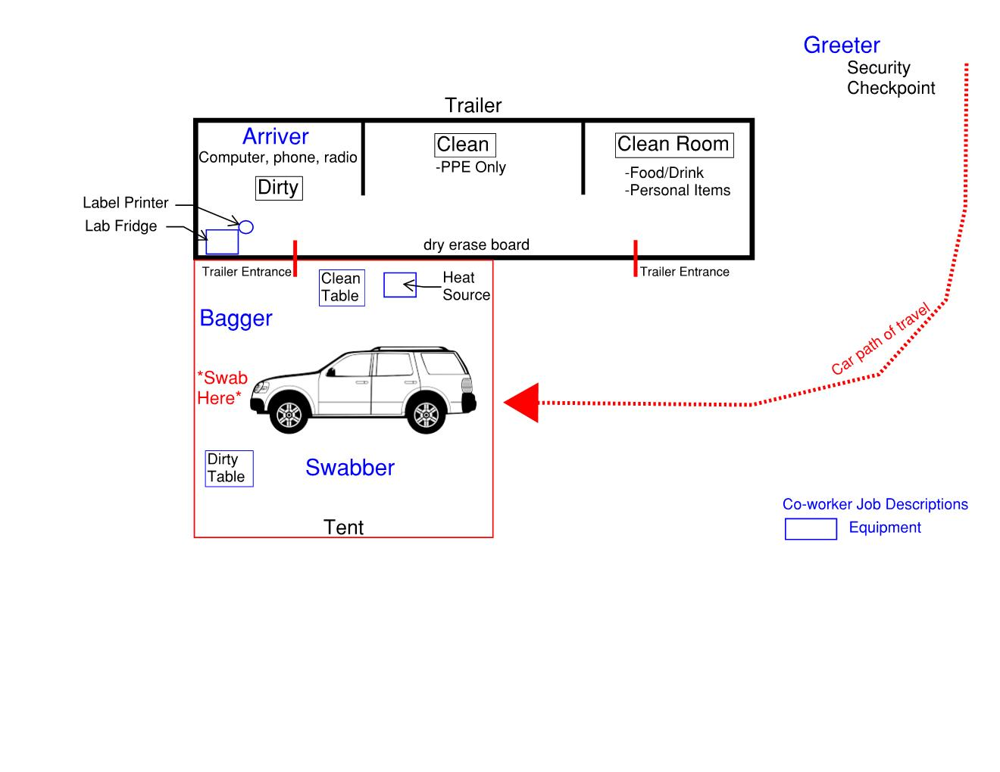

Emergency Procedures
- Patient in distress-call 911-have address posted in view of team-notify ED of incoming patient
- Inclement weather-see appendix
- Threatening patient-radio security

Site Lead Daily Standard Work
- Validate schedule for next 48 hours and prepare competency checklist
- Monitor supply level and request new supplies
- Assess site for safety and quality throughout the day with particular attention to PPE compliance, coworker resource
- Trouble shoot for pts without order or appointment

Appendix

Appendix A: Coworker FAQ’s link: Testing Center Coworker FAQs

Appendix B: Coworker Competency and Orientation
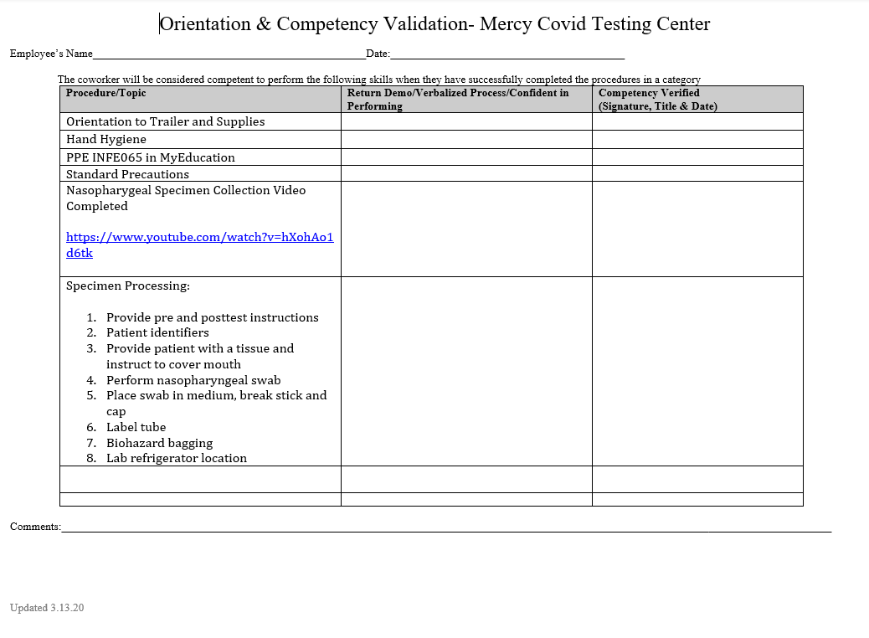

Appendix C: Mercy COVID-19 Testing Need to Know
For presenting patients not on the schedule
COVID19 TESTING
NEED TO KNOW
Thank you for visiting today. We are unable to collect your specimen as you have not completed the pre-screening and registration process.

You should request screening by calling 314-251-0500 if you are experiencing the following symptoms:
- Fever or signs/symptoms of lower respiratory illness (e.g. cough or shortness of breath) and
- Have had close contact with a laboratory-confirmed COVID-19 patient within 14 days of symptom onset or A history of travel from affected geographic areas

For general Corona/Covid19 Information, please visit the site below for the most up-to-date information:

https://health.mo.gov/living/healthcondiseases/communicable/novel-coronavirus/

How can people protect themselves?
There are steps people can take to reduce their risk of getting any viral respiratory infections. These include:
- Wash your hands often with soap and water for at least 20 seconds
- Avoid touching your eyes, nose, or mouth with unwashed hands
- Avoid close contact with people who are sick
- Avoid close contact with others
- Cover your mouth and nose with a tissue when you cough or sneeze, then throw the tissue in the trash and wash your hands
- Clean and disinfect objects and surfaces
- It is also important for people to stay at home away from others if they are sick.

NEED TO KNOW

Appendix D: Post-Test Instructions-Self Isolation
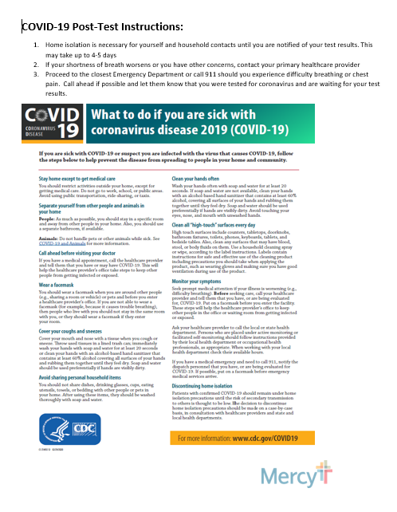

Appendix E: Inclement Weather Sign

Test Collect Site – Severe Weather Plan
- The Emergency Operations Center is constantly monitoring the weather conditions.

- Lightning
  - In the event of lightning, collection services will be suspended until the Emergency Operations Center indicates it is now safe to continue operations. Please do not wait for direction from the Emergency Operations Center to suspend services. All personnel should enter the trailer and notify the Emergency Operations Center that there is lightning in the area.

- Tornado Warnings
  - Tornado Warnings will be monitored by the Emergency Operations Center as well as Dispatch. If a Tornado Warning is called, the Emergency Operations Center will send an automated Everbridge message to the structure phone. During a Tornado Warning personnel should exit the trailer and shelter in place at the Virtual Care Center.

- Emergency Operations Center Phone #

Appendix F: Initial Equipment List

Mobile/Drive Through preferred option
1 – Follett med fridge – U/C
8 – Poly Resin Stack Chairs
3 – Task Chairs
3 – Desks (Using 1 used desk and 2 – 6’ folding tables from McCarthy)
1 or 2 – Red Step on Trash cans – 23 gal – Grainger #6GAK2

Optional Equipment for in person clinic option (not preferred)
1 – Blood draw chair
1 – physician stool
1 – BP unit with extra cuffs
1 – Oral thermometer with several boxes of probe covers
1 – Follett med fridge (at MHS)
1 – Scale
1 – Pulse Oximeter

Appendix G: Information Technology Equipment

2 – Dell 7050 PC’s
1 – Dell 7060 PC
3 - DS4308- HC barcode Scanner
3 – Imprivata HDW-IMP-60 Badge readers
3 - Dell P2419H Monitors
1 - 750 APC UPS
1 - Lexmark MX410 mono MFP printer
3 - extra toner cartridges
1 - GX420 Zebra label printer
1 - extra roll label
2 - Cisco 7962 desk phones
2 - Meraki Z3C cellular/Internet switch/routers
1 – Cisco Wireless Access Point

Appendix H: Site Build Options

Building Option:
- Hospital owned building.
- Vacant building is preferred.
- If occupied, isolate existing tenants or relocate tenants.
- Utilize the building canopy to access the mobile/vehicular patient traffic.
- If no building canopy, then will need a tent and tent walkway to cover both the coworkers and the patient vehicles.

Trailer & Tent Option:
- Small to medium size tent to house coworkers and specimen refrigerator.
- Trailer requires both toilet facilities and handwashing facilities.
- Trailer with 2 entrance(s).
- Tent required for vehicular traffic and covered walkway, with sides, from trailer to the vehicle.
- Trailer will require either generator or temp power hookup.
- Trailer will require utility hook up or tank storage of water and waste.
- Trailer maintenance (by vendor) recommended that vendor(s) step away from the tent area when patients are present. Otherwise it is virus free around the tent without PPE.

Appendix I Cleaning Electronic Devices

Facility Name(s): | Infection Prevention
Policy / Procedure: | Cleaning Electronic Devices Policy
Original Effective Date:
Version Effective Date:
Review Dates:
Revision Dates:
Supersedes:
Scope:
Issuing Authority:
Responsible Leader:
Reviewed by:
Approved by:

- Policy: Electronic Devices will be cleaned and disinfected after each patient use utilizing the hospital approved disinfectant wipes, and if available the UV disinfecting system
  - Hospital approved disinfectant wipes are EPA-registered and meet OSHA rules and regulations and CDC recommendations
  - These disinfectant wipes are used according to the manufacturer’s recommendations
  - Devices are disinfected between patients and prior to charging or placing in UV disinfecting system
  - Co-workers are to wear gloves when handling disinfectant wipes

- Purpose: Disinfection of Electronic Devices is necessary because these devices are high-touch surfaces that can serve as reservoirs for microorganisms that can cause infections in patients and co-workers. Because patients and coworkers move throughout the facility and come in contact with equipment regularly, all coworkers are expected to understand and participate in infection control activities including the appropriate disinfection of equipment.

- Scope: Policy applies to all communities, credentialed providers, and coworkers who enter a room or provide care for a patient or family who are using an electronic device.
- Definition:
  - Hospital owned Electronic tablet: A tablet that is used with the educational module within the electronic health record. Patients or their designated proxy use the device to obtain education, laboratory results or other information related to their inpatient hospitalization.
  - Electronic Devices are considered to be any portable or handheld device that is either used by a patient or used by personnel that have direct (and occasional) patient contact. o Examples of such devices Includes, but not limited to: phones, tablets, slates, keyboards, mice, remotes, laptops computers (clamshell type)
  - Ultraviolet Disinfecting System: Device offering storage, charging, and chemical free disinfection of mobile devices.
  - Contact Time: The amount of time the surface needs to stay wet after the cloth touches the surface

Procedures for Implementation
- With gloves on, clean and disinfect the Electronic Devices with the appropriate disinfectant wipe (i.e. purple or gray top/bleach wipe for enteric contact isolation) when leaving the patients room. Any time that the device is visibly soiled, the devices must be cleaned first with one wipe, then use a second disinfectant wipe for the disinfection process.
  - Use the disinfectant wipe according to the manufacturer’s recommendations
  - Assure appropriate “contact time” is followed in order for disinfectant solution to kill the microorganism.
  - Use a new wipe for each surface and wipe the entire exterior of the device

- If available, the Electronic Devices should be disinfected with the UV disinfecting system between patients or more frequently if indicated.
  - UV disinfecting system can be used to disinfect tablets, phones, watches, stethoscopes, and equipment fitting easily into the baskets.
  - Clean any visible soiling with the appropriate wipe prior to placing in the UV disinfecting system. The UV disinfecting system should be set for 120 seconds (2 minutes) for all device

- Devices used in enteric contact isolation rooms will be disinfected with bleach wipes

Related Policies and References

Neely, A.N., Weber, J.M., Daviau, P., MacGregor, A., Miranda, C., Nell, M., Bush, P., &
Lighter, D. (2005). Computer equipment used in patient care within multihospital system: Recommendations for cleaning and disinfection. American Journal of Infection Control, 33 (4), 233-237.

Center for Disease Control and Prevention, Hospital Infection Control Practices Advisory
Committee. Guideline for Isolation Precautions: Preventing Transmission of Infectious Agents

Title: MW IP Cleaning Electronic Devices Policy

in Healthcare Settings, 2007. Guideline for Isolation Precautions: Preventing Transmission of Infectious Agents in Healthcare Settings (2007)
Refer to Policy tech for Approvals

Appendix J: Site Lead Recommended Daily Standard Work

TIME | TASK | NOTES-Delegate as needed | COMPLETED
715 | Arrive-prep for the day | lights, check temp, review schedule for volume | ▪
730 | Welcome new coworkers for orientation-assign roles: greeter, swabber, bagger. Review device cleaning. | Complete Competency validation record for each new coworker | ▪
800 | Receive first patient |  | ▪
All day while collections are occurring | Provide support to team: point of contact to resolve issue. Observe for PPE breaches and coach. Monitor supplies and secure if low. Insure specimens have been picked up by courier. Report needs to command center. Update communication white board with new info for coworkers. |  | ▪
1100 & PRN | Insure outer surface of lab fridge, phones, radios, tablets and surfaces are disinfected |  | ▪
1200 | Welcome new coworkers for orientation-assign roles: greeter, swabber, bagger |  | ▪
By end of day | Review schedule for open shifts and work with you community scheduler to fill |  | ▪
By end of day | Prepare competency validation record for any next day new coworkers |  | ▪
By end of day | Report daily volume and no shows to command center |  | ▪
By end of day | Check nourishment for next day |  | ▪
By end of day | Check label printer-do you need a new roll? |  | ▪
By end of day | Print or request printing of educational materials |  | ▪
Closing | Bring supplies in from outside, double bag any used goggles for disinfecting, place radios on chargers, lock doors |  | ▪

Appendix K: Public Safety Recommendations

- Traffic Control:
  - Due to the fear, illness and confusion of patients traffic should be routed in the easiest and safest travel path available.
    - Stress that no occupants should ever leave a vehicle.
  - Entrances should be away from high traffic roadways with easy ability to turn away patients without appointments
  - Traffic control devices:
    - Traffic cones
    - Traffic barricades
    - Plastic Chains
    - Mercy approved signage
    - Manuel access control gate

- Site Security:
  - A minimum of two officers are required for site security
    - One officer to man main entry point
    - Second officer to provide test building support
  - Work with local Law Enforcement from inception through operation for security support
  - Officers well versed in de-escalation for patient interactions
  - Additional officers or local law enforcement may be needed for additional site security to keep individuals from approaching test collection site from unplanned routes i.e., foot traffic, adjoining parking lots, or open areas.
- Communications:
  - (4) Four UHF/VHF radios are needed at each site for proper communication.
    - Main entrance
    - Inside test collection site for Arriver
    - Outside at actual collection location
    - Second security officer

